**CPP Lab**

**Assignment-4**

**Name-Ashish Goyal**

**Id-2016ucp1100**

**Batch-A (1, 2)**

1. **Implement solution of Critical Section problem with Semaphores (two processes).**

**CODE-**

//gcc a1.c -lpthread -lrt

#include <stdio.h>

#include <pthread.h>

#include <semaphore.h>

#include <unistd.h>

sem_t semaphore;

int common=0;

void* thread(void* arg)

{

char* msg=(char*)arg;

while(1)

{

sem_wait(&semaphore); //waiting

printf("\n%s-Entered critical section\n",msg);

//int value;

//sem_getvalue(semaphore,value) ;

//printf("%d\n",value);

sleep(1); //critical section

common++;

printf("\ncommon value-%d\n",common);

printf("\n%s-Exiting critical section\n",msg);

sem_post(&semaphore); //signal

}

}

int main()

{

sem_init(&semaphore,0,1); //binary semaphore

pthread_t t1,t2;

char* msg1="Thread1";

char* msg2="Thread2";

pthread_create(&t1,NULL,thread,msg1);

sleep(3);

pthread_create(&t2,NULL,thread,msg2);

pthread_join(t1,NULL);

pthread_join(t2,NULL);

sem_destroy(&semaphore);

return 0;

}

**OUTPUT-**

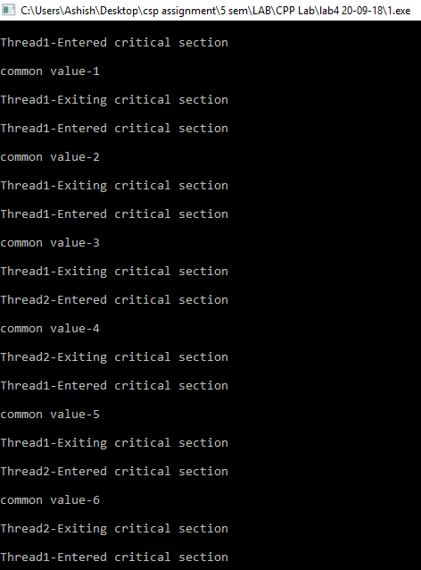

1. **Implement solution of Critical Section problem with Semaphores (N processes).**

**CODE-**

#include <stdio.h>

#include <pthread.h>

#include <semaphore.h>

#include <unistd.h>

sem_t semphore;

int common=0;

void* thread(void* arg)

{

int message=(int)arg;

while(1)

{

sem_wait(&semphore);

printf("\nThread %d-Entered critical section\n",message);

sleep(3);

common++;

printf("\ncommon value-%d\n",common);

printf("\nThread %d-Exiting critical section\n",message);

sem_post(&semphore);

}

}

int main()

{

sem_init(&semphore,0,1);

pthread_t thr[10];

int i;

for(i=0;i<10;i++)

{

pthread_create(&thr[i],NULL,thread,i);

sleep(2);

}

for(i=0;i<10;i++)

{

pthread_join(thr[i],NULL);

}

sem_destroy(&semphore);

return 0;

}

**OUTPUT-**

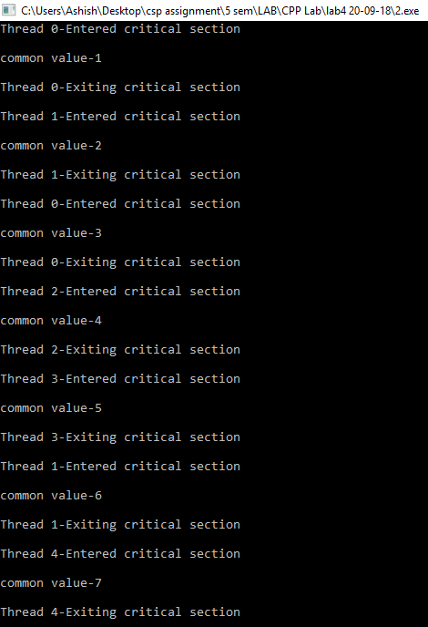

1. **Implement producer-consumer problem with Semaphores (infinite buffer).**

**CODE-**

#include <stdio.h>

#include <stdlib.h>

#include <unistd.h>

#include <time.h>

#include <pthread.h>

#include <semaphore.h>

#define SIZE 100000 // size of the queue(queue of product)

int queue[SIZE];

int tail,head;

sem_t notfull,notempty;

void *producer(void *arg)

{

int val;

do

{

int val=rand()%100;

printf("produced product number: %d\n",val);

queue[tail]=val;

tail=(tail+1)%SIZE;

sem_post(&notempty); /* increment number of products in the queue */

sleep(rand()%5); /* rest after product produce */

}while(val);

}

void *consumer(void *arg)

{

int val;

do

{

sem_wait(&notempty); /* wait for products in queue */

val=queue[head];

head=(head+1) % SIZE;

printf("consumed product number: %d\n", val);

sleep(rand()%5); /* consume the product */

}while(val);

}

int main(int argc,char *argv[])

{

pthread_t product,consume;

sem_init(&notfull,0,SIZE); //middle zero means sharing b/w thread

sem_init(&notempty,0,0);

pthread_create(&product,NULL,producer,NULL);

pthread_create(&consume,NULL,consumer,NULL);

pthread_join(product,NULL);

pthread_join(consume,NULL);

sem_destroy(&notfull);

sem_destroy(&notempty);

return 0;

}

**OUTPUT-**

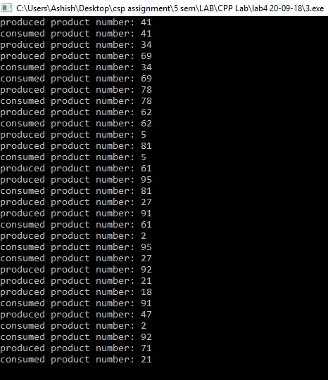

1. **Implement producer-consumer problem with Semaphores (finite buffer)**

**CODE-**

#include <stdio.h>

#include <stdlib.h>

#include <unistd.h>

#include <time.h>

#include <pthread.h>

#include <semaphore.h>

#define SIZE 20 // size of the queue(queue of product)

int queue[SIZE];

int tail,head;

sem_t notfull,notempty;

void *producer(void *arg)

{

int val;

do

{

int val=rand()%100;

printf("produced product number: %d\n",val);

sem_wait(&notfull); /* wait for empty place in queue */

queue[tail]=val;

tail=(tail+1)%SIZE;

sem_post(&notempty); /* increment number of products in the queue */

sleep(rand()%4); /* rest after product produce */

}while(val);

}

void *consumer(void *arg)

{

int val;

do

{

sem_wait(&notempty); /* wait for products in queue */

val=queue[head];

head=(head+1) % SIZE;

printf("consumed product number: %d\n", val);

sem_post(&notfull); /* increase free spaces in the queue*/

sleep(rand()%5); /* consume the product */

}while(val);

}

int main(int argc,char *argv[])

{

pthread_t product,consume;

sem_init(&notfull,0,SIZE); //middle zero means sharing b/w thread

sem_init(&notempty,0,0);

pthread_create(&product,NULL,producer,NULL);

pthread_create(&consume,NULL,consumer,NULL);

pthread_join(product,NULL);

pthread_join(consume,NULL);

sem_destroy(&notfull);

sem_destroy(&notempty);

return 0;

}

**OUTPUT-**

